**An optimized microchannel Ta target for high-current accelerator-driven neutron sources**

Qi Ding1,2,Ulrich Rücker1, Paul Zakalek1, Johannes Baggemann1, Jörg Wolters3, Jingjing Li1, Yannick Beßler3, Thomas Gutberlet1, Thomas Brückel1, Ghaleb Natour2,3

1Jülich Centre for Neutron Science JCNS-HBS, Forschungszentrum Jülich GmbH, 52425 Jülich, Germany

2Faculty of Mechanical Engineering, RWTH Aachen University,52056 Aachen, Germany   
3Central Institute of Engineering, Electronics and Analytics ZEA-1, Forschungszentrum Jülich GmbH, 52425 Jülich, Germany

**Abstract**

An optimized neutron producing tantalum target with an optimized internal microchannel cooling was developed for a 70 MeV proton beam with a peak current of 100 mA, a duty cycle of 1.43 % and an average power of 100 kW on a target surface area of 100 cm². In this work a target with microchannel cooling structure is described which matches with the proton’s energy to minimize hydrogen implantation and to produce energy deposition with optimum homogeneity inside the target to minimize the thermal stresses. For the purpose of getting an optimal target design, the investigations of energy deposition, proton fluence, the spatial distribution of (p, n) reactions and the spatial distribution of stopping protons of the target with different microchannel geometries were performed with the particle transport code FLUKA. The resulting design produces a homogeneous proton fluence and energy deposition without hot spots. Furthermore, only 4.4% of the impinging protons accumulate in the metal target, which significantly decreases the risk of hydrogen embrittlement and blistering.

**Keywords:** proton beam, target, microchannel cooling, FLUKA, HBS, Hi-CANS

**1 Introduction**

Neutron scattering and neutron analytics are powerful methods for fundamental and applied research in sciences as well as in many technical and industrial fields [1]–[4] Suitable neutron sources with desired intensity, reasonable dimensions and low overall expenses are required. With the ongoing decommissioning of older fission-based neutron sources, the demand for accelerator-driven neutron sources has increased worldwide. Responding to this situation, the High Brilliance neutron Source (HBS) project [5]–[9] was initiated at the Jülich Centre for Neutron Science (JCNS) of the Forschungszentrum Jülich GmbH, which aims to deliver high brilliant neutron beams to a variety of neutron instruments. In the framework of this project a high-current accelerator-driven neutron source (Hi-CANS) [7], [8], [10], [11] has been proposed to produce high-brilliant neutron beams by proton induced nuclear reactions with an energy well below the spallation threshold. Such a Hi-CANS should not only have a high neutron yield, but also have a stable long-term service life. This requires all the core components to be designed properly. Especially the target, which is one of the central elements for neutron production.

Previous investigations [12] suggest that different materials are preferable for different ion energy ranges. For example, the low-Z materials, Be and V, generate more neutrons at proton beam energies below 20 MeV. However, for ions’ energies above 50 MeV, high-Z materials e.g., Ta and W, are preferable [12]. Tungsten is a non-reactive material, which endo-thermally dissolves hydrogen. In contrast, the solution of hydrogen in tantalum is an exothermic process. Hence, tantalum has a higher hydrogen solubility (0.76 H/M at 100 °C and 1 atm [13]) compared with tungsten (1.3 × 10-19 H/M at 100 °C and 1 atm [14]). Here the hydrogen solubility is expressed as the atomic ratio of hydrogen (H) to metal (M) at 100°C and 1 atm. Correspondingly, tantalum can accumulate a large amount of hydrogen and the blistering threshold is up to 0.17 H/M at room temperature and 1 atm [15], [16]. Tantalum's capacity to store large amounts of hydrogen inhibits blistering and thus benefits the life of the target. In addition, tantalum exhibits a good machinability and weldability. Besides, tantalum possesses a high melting point of 3017 °C as well as excellent thermal performance and mechanical properties, especially pure tantalum displays excellent ductility even after irradiation [17] . Therefore, tantalum has been chosen as the target material for the HBS project.

Table 1 Main parameters of the HBS target [18]

|  |  |
| --- | --- |
| Target material | Tantalum |
| Particle type | Proton |
| Particle energy | 70 MeV |
| Peak current | 100 mA |
| Duty cycle | 1.43 % |
| Average power | 100 kW |
| Peak power | 7 MW |
| Average neutron yield | 1.45×1015 s-1 |

The main parameters of the HBS target are summarized in Table 1 [18]. At HBS, the accelerator delivers proton currents of 100 mA and 70 MeV energy with a duty cycle of 1.43% to impinge on the target. The high average proton current of 8.74×1015 s-1 might cause hydrogen embrittlement and blistering problems. Over time, protons resting inside the tantalum target can trap electrons and thus form atomic and molecular hydrogen, which eventually accumulate into hydrogen bubbles. The hydrogen atoms inside the target can penetrate into the solid tantalum, which leads to lower the stress required for crack generation and extension in the tantalum; or to form brittle hydrides, which results in enhancing brittleness and decreasing tensile strength, the so-called hydrogen embrittlement [19]. On the other hand, atomic hydrogen diffusing through the tantalum target may accumulate at internal defects like inclusions and laminations and form molecular hydrogen. High pressures may build up at such locations due to continued absorption of hydrogen leading to blister formation, growth and eventual bursting of the blister, which results in localized deformation or even destroys the walls of the vessel [20], [21]. In order to avoid these problems, we have chosen a geometry, where the thickness of the target is reduced to be slightly thinner than the penetration depth of 70 MeV protons, so that most of the impacting protons end up dumped in a water sink (“proton pool”) on the backside of the target, which is simply called “beamstop”. The other potential issue endangering the target integrity is thermal stresses due to the large volumetric heat load release in the small target volume of 60 cm3. For this a reliable cooling should be guaranteed for the target during the operation in order to avoid local hot spots due to overheating. Correspondingly, we propose an optimized internal cooling microchannel structure [22], [23] with sufficient cross-sectional area of channels to dissipate heat. The cooling substance chosen is light water, which is not critical and can be obtained easily. In addition, water has a very good heat capacity, high density and a wide temperature range in the liquid phase, which results in being effective in heat dissipation, and water is easy to handle. It is hardly activatable compared to metals and it is easier to be sealed compared to gases. Besides, no corrosion has been observed when tantalum is in contact with water under irradiation [24]. Another problem is that the heat deposition in the target is not homogeneous as protons have different scattering cross sections and thus penetration depths in tantalum and water, which leads to temperature gradients and then to induced thermal stresses. For this, a microchannel structure which can produce a homogeneous energy deposition should be determined. Therefore, to engineer a reliable target it is necessary to develop a design that minimizes hydrogen implantation and features a cooling system that efficiently removes heat and produces homogeneous energy deposition within the target. Objectives, potential problems and mitigations and partial constrain conditions are listed in Table 2.

Table Objectives, potential problems and mitigations for target optimization

|  |  |  |  |
| --- | --- | --- | --- |
| Design goals | Potential issues | Mitigations | Constraints |
| (1) Minimum proton implantation,  (2) Homogeneous energy deposition  (3) Sufficient cross-sectional area of cooling channels  (4) Maximum neutron yield [12] | (1) High proton (peak) current of 100 mA | Optimize microchannel structure  (1) to have enough cooling area  (2) to produce homogeneous heat deposition  (3) to minimize proton implantation | (1) Microchannel thickness 0.35 mm;  (2) 1.2 mm² of cross section of water channels on every mm of target width;  (3) Number of elements of microchannel structure must be more than one |
| (2)100 kW heat (average) release in a small target of 60 cm3 |
| (3) Inhomogeneous heat deposition |

**2 Microchannel structures of the target**

The principle of a metal target with microchannel cooling structures can be described as following the schematic drawing depicted in Fig.1. The gray part shows the solid tantalum, and the white microchannel structures are filled with water. As the power density of the HBS project is up to 1 kW/cm2 and the target is just 0.61 cm thick, the power density is very challenging from a cooling perspective. For this the contact area with the tantalum to be cooled must be sufficiently large in order to efficiently remove the entire heat via the water coolant. P. Mastinu et al [25] have shown that a microchannel structure with water coolant was able to remove heat up to 3.5 kW/cm². A “fin structure” is adopted to increase the cooling surface area. The diameter of the microchannels is chosen as 0.35 mm for a high heat transfer coefficient (17.000 W/m²/K with 8 m/s coolant velocity) to obtain a sufficient cooling efficiency [18]. The target consists of several individual microchannel structures as shown in Fig.1 instead of a long microchannel structure throughout the entire target width, which minimizes bending stresses caused by the static pressure of water. The estimated pressure at the target inlet is 5 – 6 bar. The pressure loss in the target is approx. 2 bars. The solid tantalum parts between these single microchannel structures are abbreviated as “bridges” in the following texts. The water beamstop behind the target offers additional cooling at the target’s backside with the highest heat deposition. Each of the individual microchannel segments are cut out via wire erosion. The starting holes for this process are fabricated via sinker electrical discharge machining [26].

The arrows in Fig.1 represent straight paths of protons inside the target, the ends of arrows are the positions of terminated protons. Fig.1 shows the protons in different paths traveling through different amounts of metal tantalum and water. For example, the protons crossing the bridge sections only travel through tantalum (like “C”). However, some protons traversing the microchannel structures go through the paths containing tantalum and water (like “A” and “B”), which results in an inhomogeneous distribution of stopped protons as protons have different penetration depths in tantalum and water. Correspondingly, the heat deposition in the target is also inhomogeneous. In order to avoid these issues, some tantalum in the bridge sections should be removed to match with the part of microchannel structures owing water and tantalum, which can be depicted as grooves where “D” and “E” cross through in the right part of Fig.1. In addition to the bridge sections, even for the protons impinging at the same microchannel structure, the amounts of water and tantalum in different paths are also different. For instance, some protons only travel through the main horizontal channel (like “B”) but the other also go through the fins in addition to the main channel (like “A”). Therefore, a proper microchannel structure, which has sufficient cross section area of cooling and can minimize proton accumulation and also can produce homogenous energy deposition inside the target, needs to be determined.

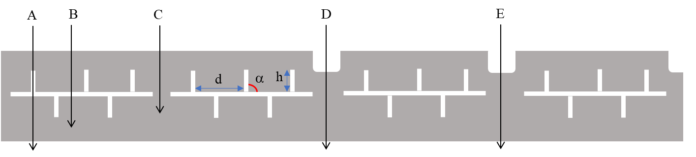

Fig. The schematic of a tantalum target with microchannel structures

Note: d is the distance between neighboring fins, h is the height of a fin, α is the angle of a fin

The straight trajectory of protons depicted in Fig.1 is the ideal situation. The realistic physical paths of impinging protons are far more complicated than that because of the collisions of protons with other particles or target nuclei atoms. Usually, the protons are forced to deviate from the straight track after a collision and the paths become straggling. Therefore, this work adopts the particle transport code FLUKA 2020.0 [27], [28] as the tool to simulate the process of protons bombarding the tantalum target to determine a proper microchannel structure. The key parameters to determine a proper microchannel structure are the angle α, the height h of the fins and the distance d between the neighboring fins as shown in Fig.1. The details of the investigation and the resulting microchannel design will be presented in section 4 (Results and discussion).

**3 Numerical method**

All the simulations in this work are performed with the particle transport code FLUKA 2020.0 for GNU/Linux operating system, which is a fully integrated particle physics simulation package. The cross-sections for all simulations are taken from ENDF/B-8R0 [29] and JENDL40-HE [30].

The geometrical model utilized for the FLUKA simulations is depicted in Fig.2. The simulated geometry includes all details of the neutron-producing center of the target. The outer edge of the target and the cooling water connections are not simulated. The proton beam is a monoenergetic beam of 70 MeV, which is defined as a rectangular volume source, emitting the protons homogenously along Z (the target depth) direction. The beam surface covers the facing target surface completely. The assumption of a rectangular volume source is valid because the proton beam in the HBS project is scanned over a rectangular portion of the target with a high focus of only a few centimeters beam diameter. The volume of the rectangular metal target is 10×10×0.61 cm3. The microchannel structures are filled with water. The beamstop at the backside of the metal target is 0.8 cm thick. The beamstop is filled with water to provide additional cooling at the target backside and to stop the protons. All water in this work is considered as liquid without bubbles at room temperature and standard atmospheric pressure. A thin layer of tantalum (0.2 cm) behind the beamstop is used as a structural material and to prevent proton leakage from the beamstop. The target actually is composed of 5 identical pieces with the same microchannel structures. Thus, the “lattice card” is used to replicate the periodic geometry when building the simulated model. The whole geometry has to be contained in a closed blackhole to absorb all escaping particles. This boundary condition is applied for all the simulations in this work.

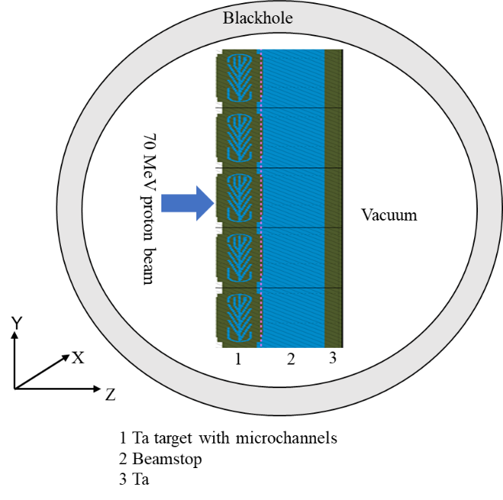

Fig. 2 Target geometry for simulations with FLUKA

Concerning the energy deposition and proton fluence, the USRBIN estimator is selected to score the pertinent quantities. The (p, n) reactions occurring in the whole target were recorded with the USEEDUMP card. The information cannot be obtained through the standard options of FLUKA. Thus, an advanced subroutine, the USDRAW entry of the MGDRAW was modified accordingly to record the 3-dimensional coordinates of the (p, n) reactions. The USEEDUMP card is also utilized to record the spatial distribution of stopped protons. Analogously, the ENDRAW entry of the MGDRAW routine is also customized correspondingly. In order to reduce the statistical errors sufficiently, the number of primary source particles to be simulated was always set to 5×106. The computation time of such a simulation is about one hour with Intel(R) Xeon(R) Gold 6154 CPU @ 3.00GHz.

**4 Results and discussion**

**4.1 Bragg curves of 70MeV protons**

The knowledge of the proton penetration depth versus stopping power curves, or “Bragg curves,” is a fundamental prerequisite for the investigations in the neutron producing target design. According to [31], a Bragg curve plots the energy loss of ionizing radiation during its travel through matter. Hence, we used FLUKA to calculate the energy deposition [MeV/cm/primary] (i.e. energy loss) of protons along the target depth during its travel through tantalum and water respectively.

For [a](https://www.sciencedirect.com/topics/engineering/heavy-ion) high current proton beam bombarding a tantalum target, nuclear reactions along the penetration path lead to a build-up of neutron production and also an accumulation of stopping protons and an enormous energy being deposited towards the backside of the metal target. However, the protons resting within the tantalum target can lead to hydrogen implantation, and the heat deposition can cause stress problems. Thus, it is important to find out how the specific ionization is distributed along the path of the particle. Such a distribution, for a monoenergetic 70 MeV proton beam in solid tantalum and liquid water, is shown in Fig. 3 (a) and (b), respectively. Apparently, both the resulting depth-energy profiles (Bragg curves) exhibit a flat plateau region at the beginning of the track and a distinct peak near the end range of the particles. (Note, a monoenergetic homogenous volumetric proton beam perpendicularly impinges from left perpendicular on the target.)

From the curves in Fig.3 the penetration depth of 70 MeV protons in tantalum and water can be determined as 0.55 cm and 4.25 cm, respectively. The stopping range of tantalum for 70 MeV protons is about 7.8 times shorter than for water. Theoretically, a target with a thickness more than the penetration depth of ions is thick enough to stop all protons within the target. For a distinction, this work will define such a target as a thick target, e.g. 1 cm tantalum target in Section 4.2. And a target with a thickness thinner than the penetration depth will be called a thin target.

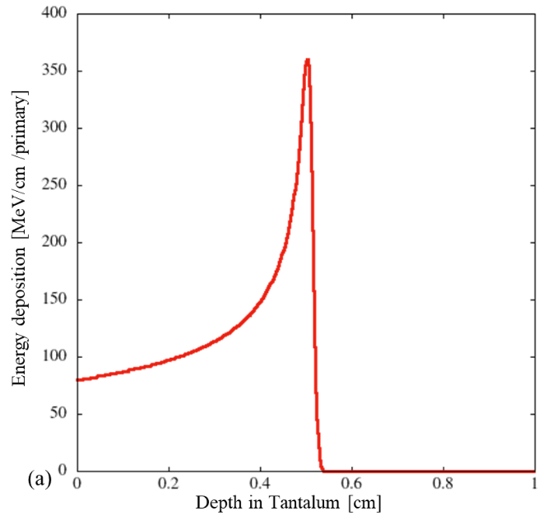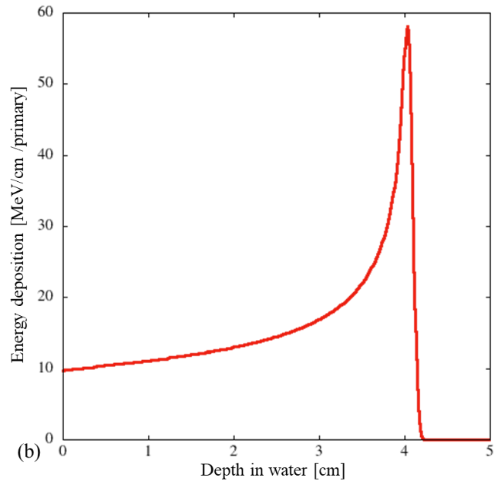

Fig. 3 Bragg curve of a 70 MeV proton beam in (a) Tantalum and (b) Water

**4.2 Thick target**

In order to create a target design with a periodic microchannel cooling structure which minimizes proton implantation and possesses sufficient cross-sectional area of cooling and homogenizes energy deposition, a microchannel structure as shown in Fig.1 was optimized. The main optimized parameters are listed in Table 3.

Table 3 Main optimized parameters of the microchannel structure of a thick target

|  |  |  |
| --- | --- | --- |
| Optimized parameters | Values | Steps |
| Angle of the microchannels α | 0o -30o | 0.5o |
| Height of the microchannels h | 0.7- 6 mm | 0.2 mm |
| Distance between neighboring channels d | 0.4- 8 mm | 0.2 mm |
| Number of fins of each straight trajectory n | 0-4 | 1 |

The parameter optimization is a manual step by step process. The optimization process can be described in the following workflow diagram as shown in Fig.4.

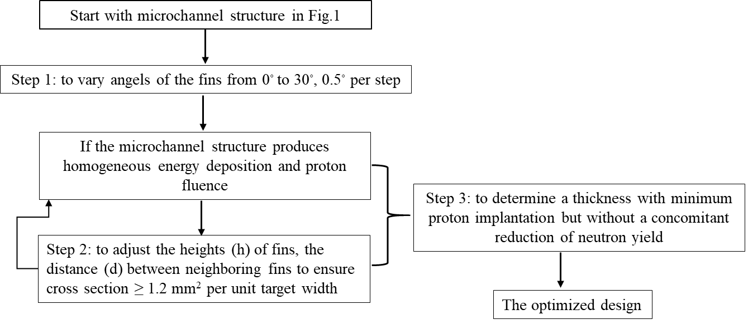

Fig. Workflow diagram for target optimization

According to the investigation of the parameter optimizations, it turns out that two conditions are necessary for a proper microchannel structure to get a homogeneous energy deposition and also the proton stopping distribution. The first condition is to ensure that the part of the distance covered by every proton over a straight, undistributed path in the target that goes through Ta metal is the same, no matter if the proton travel through the center of the microchannel structure, through an end section, or through a bridge between two microchannel structure elements. The second condition is that the y-coordinate of Fig.5 of the connection of any fin to the central water channel coincides with the y-coordinate of the end of a fin on the opposite side of the central channel.

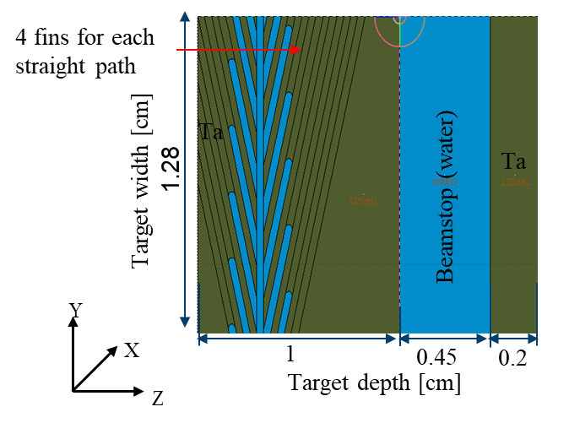

Fig. 5 A slice of a thick target with periodic microchannel structures

In a target with a microchannel structure as shown in Fig.5, a straight trajectory of each impinging proton, e.g. the red arrow in Fig.5, intersects 4 fins as well as a main water channel. Besides, the beginning of one microchannel fin on one side always coincides with the end of the second next fin on the opposite side. The main parameters of the thick target are listed in Table 4. The angle of the microchannel fin with respect to the main channel is α=14.5o, the height of the microchannel fin is 0.141 cm and the distance between neighboring channels is 0.267 cm. The thickness of the tantalum target on the right side is 1 cm. With such a thick target, all protons are stopped in tantalum so that the Bragg peak position can be determined. In this way, a proper target thickness which is slightly smaller than the penetration depth of protons but without a concomitant reduction of neutron yield can be obtained.

Table 4 Main parameters of a slice of a thick target

|  |  |
| --- | --- |
| Parameters | Values |
| The angle of the microchannels α | 14.5o |
| The height of the microchannels h | 0.141 cm |
| The distance between neighboring channels d | 0.267 cm |
| The number of fins of each straight trajectory n | 4 |

For the purpose of obtaining a proper target thickness to alleviate hydrogen implantation but without the associated loss of neutron output, the percentage of stopping protons, the percentage of neutron production and the percentage of energy deposition as a function of depth in the thick target are shown in Fig.6. The percentages have been normalized by dividing the total number of corresponding quantities in the target. The green curve shows the ratio of stopping protons along the target depth, which remains at an almost constant level until a steep step at a target depth of 0.61 cm. To be more specific, it is only 4.6% of protons are implanted where the target is 0.61 cm thick but 95% of protons accumulate in the subsequent narrow interval of 0.04 cm. The stopping protons include the primary and secondary protons, and it is same for the other results associated with protons. Besides, according to the red curve of the percentage of neutron production over the target depth, it indicates that the neutron production induced by 181Ta (p, n) 181W goes up with an increase in the target depth reaching up to 99% at the target depth of 0.61 cm, where only 4.6% of protons are implanted. Correspondingly, the Bragg peaks would appear in the beamstop (water channel) behind the thin metal target. Analogously, the accumulated energy deposition was also normalized and plotted along the target depth as shown in yellow curve of Fig.6, which directly depicts the percentage of heat load along the target depth. The yellow curve shows the percentage of energy deposition increases steadily towards the end of the target and reaches 100% at the target depth of 0.65 cm. With the intention of reducing heat load and minimizing hydrogen implantation in the target but also maximizing neutron production, the target thickness should not be thicker than 0.61 cm. Fig.6 shows just 76% of the heat load is deposited in the target and 24% of the heat load can be shifted towards the beamstop when the target thickness is reduced to 0.61 cm.

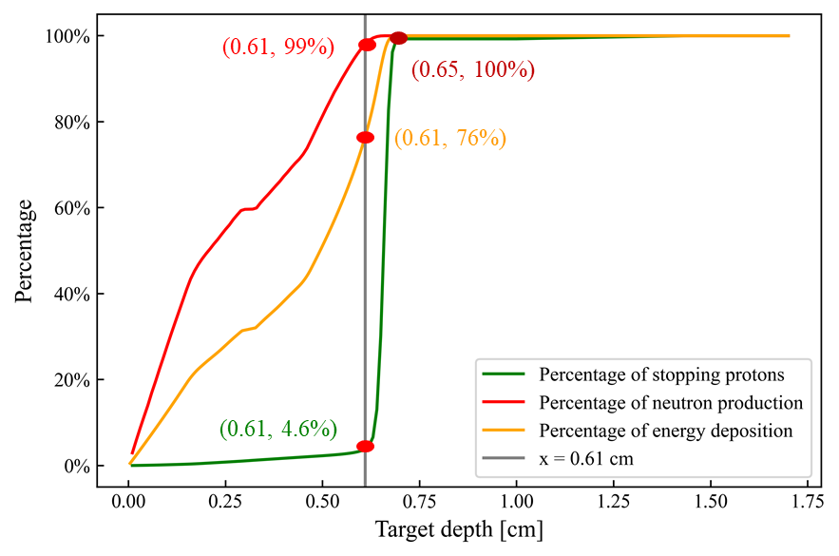

Fig. 6 Percentage of stopping protons, neutron production by 181Ta (p, n) 181W and energy deposition along target depth of the thick target

**4.3 Thin target**

To determine a realistic target structure, the thickness is set according to the results of the previous section 4.2. In addition, the periodic microchannel structure needs some ends to mechanically connect the top and bottom half of the target. Therefore, a complete thin target as shown in Fig.7 is obtained based on the thick target with microchannel structures as presented in Fig.5. The main parameters of a periodic microchannel structure (part A in Fig.7) are summarized in Fig.8. The distance between the bridges and the width of the bridges can be determined by the mechanical properties of the target material to avoid too much bending stress due to the water pressure inside the microchannel structure. The total interface area between tantalum and coolant water is 9.5×104 mm2 with 164 mm2 free flow cross section. In order to avoid proton implantation at the bridge sections, tantalum is symmetrically removed at the corresponding parts to ensure a homogeneous proton energy loss throughout the whole target so that the Bragg peak appears in the beamstop. Given the notch effect [32], each microchannel structure ended with rounded segments with maximum possible radius to minimize uneven stress distribution. Analogously, the tantalum at both sides of the rounded segments are slightly removed to prevent hydrogen accumulation caused by the stopping protons there.

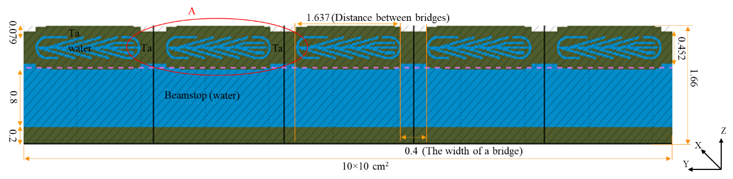

Fig. 7 Schematic of a complete thin target

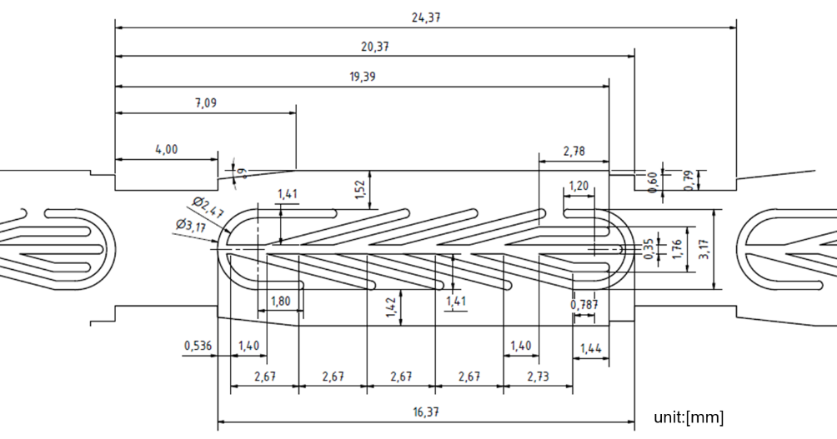

Fig. 8 Technical parameters of a periodic microchannel structure

The spatial information of proton fluence and energy deposition for the whole thin target are presented in Fig.9. The proton fluence as shown in the Fig.9(a) is nearly homogeneous within the tantalum target. Within the beamstop, the proton fluence decreases, indicated by the color transition from red to yellow, which reveals the protons deposit in the sites of fluence decreasing. This transition appears already inside the tantalum at the bridge sections between the microchannel structures due to some protons crossing the steep edges which are scattered into the ambient solid tantalum. Those protons pass through additional tantalum, so that the corresponding Bragg peak appears earlier compared to the situation when the protons are crossing water channels. On the contrary, some protons entering the grooves are scattered into the rounded end segments. As a result of passing through water instead of tantalum, those protons would have more energy to traverse a longer distance, which creates the small convex purple peaks occurring at the end of the transition zone in the beamstop. This is inevitable since some protons which cross through the tangential interface between water and tantalum at the boundaries of the bridge sections can always be scattered into the ambient solid tantalum or water channels randomly. Apart from the fluctuations in the bridge sections, the proton distribution in the central parts of the individual microchannel structures is homogeneous. It can be inferred from the straight dark blue line that the penetration depth of most protons through the central regions is the same. Fig.9(b) shows a homogeneous energy deposition within the complete target, which can significantly reduce thermal stresses caused by temperature gradients. The stopping power for protons is a function of its energy and therefore the penetration depth according to the Bragg curve in Fig.3. The incremental energy loss increases with reduced particle’s energy and reaches a maximum value at the Bragg peak, shortly before the energy drops to zero. This exactly explains that the deposited energy gradually increases towards the end of the target. The dark purple regions in the beamstop correspond to the Bragg peaks of protons through the central parts of the microchannel structures. This also proves that this target design can efficiently alleviate the heat load in the metal target.

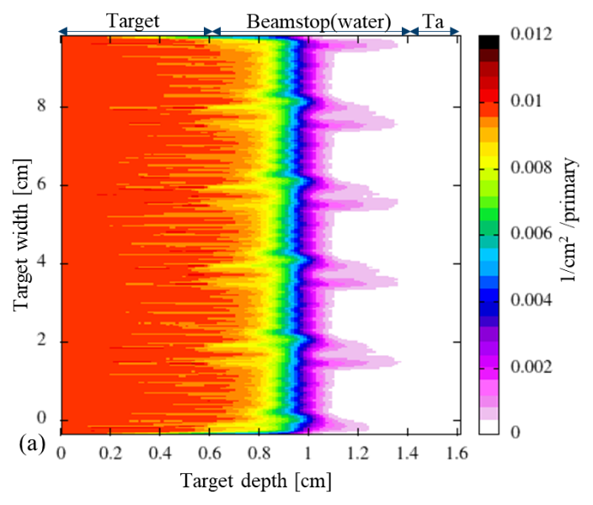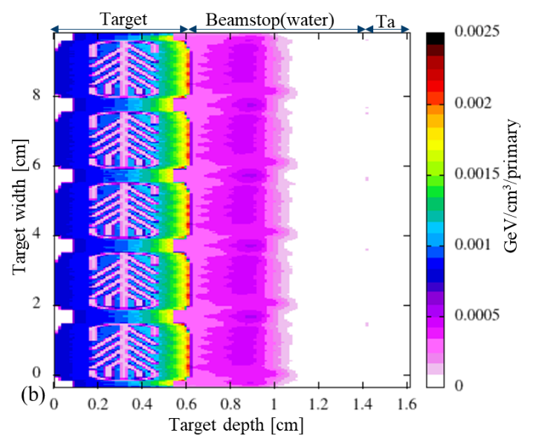

Fig. 9 (a) Proton fluence and (b) Energy deposition of the complete target

The key to minimize the risk of hydrogen damage is to minimize the number of protons accumulating in the tantalum. For this, the spatial distribution of stopping protons in the complete thin target is recorded correspondingly as shown in Fig.10(a). As apparent in Fig.10(a), most protons accumulate in the blue region, i.e. most of the protons are dumped into the beamstop (“water channel”) at the backside of the tantalum target. There are nearly no protons accumulating in the metal target except few spots at the end of the bridge sections. One probable explanation for these spots is some protons crossing the steep edges of the bridge sections are being scattered back into the solid tantalum. Those protons traverse more tantalum, which results in losing all energy and ultimately rest inside the target. The small spots exactly correspond to the concave peaks in the proton fluence presented in Fig.9(a).

The percentage of the stopping protons over the target depth is plotted in Fig.10(b). Only 4.4% of protons accumulate in the metal target and 95.1% of protons stop in the beamstop. Even only 0.5% of protons arrive to the tantalum wall behind the beamstop, which states the current target design results in a well-defined Bragg peak positioned inside the water beamstop minimizing the accumulation of protons within the target. This work also tried to decrease the percentage of protons accumulating in the target, it turns out 4.4% is already the optimal situation which is not sacrificing the neutron yield. Most of the protons lost inside the target have experienced a (p, n) reaction event or a scattering event with a Ta nucleus, which leads to a strong energy loss or a strong deviation from the original flying direction, so that they cannot reach the beamstop.

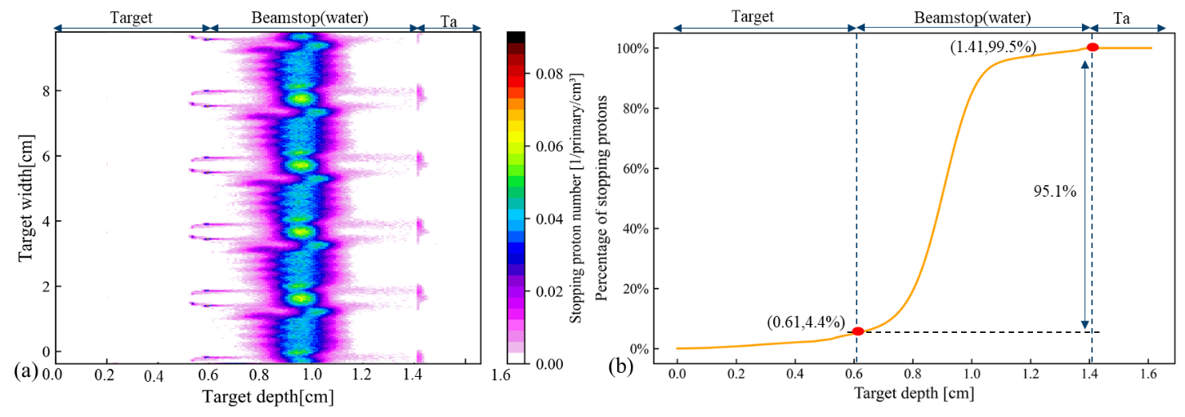

Fig. 10 (a) The spatial distribution of the stopping protons and (b) Percentage of stopping protons along the target depth of the complete target

In addition to prevent hydrogen implantation and inhomogeneous energy deposition, this work also optimized the target design for a high neutron output. The pattern of neutron production of the target is as expected, based on the obtained distribution of the 181Ta (p, n) 181W reactions in the thin target and the number of neutrons produced by181Ta (p, n) 181W events along the target depth, depicted in Fig.11. Most 181Ta (p, n) 181W reactions take place in the metal Ta of the target. The blue region at the beginning of the target indicates most neutrons are produced where the energies of the protons are highest. The amount of the neutrons becomes lower towards the end of the target. In the beamstop and also the tantalum wall behind the beamstop nearly no neutrons are produced as the proton energy threshold is 10 MeV for 181Ta (p, n) 181W reactions [29]. This also states the thickness of 0.61 cm of the thin target is a proper choice for 70 MeV protons to produce a high neutron output.

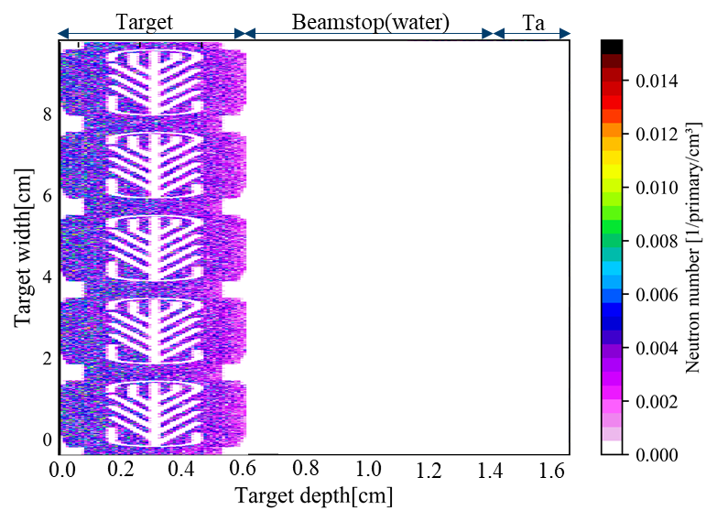

Fig. 11 Neutron distribution produced by 181Ta (p, n) 181W reactions for the complete target

Considering the manufacturing and maintenance expenses, the HBS target is expected to have a service period as long as possible. This work thus also calculated the DPA (Displacement per atom), a unitless physical quantity standard indicator for radiation damage in materials, to estimate the target’s lifetime. The induced damage is dominated by protons and neutrons, which is consistent with the results in the literature [33]. The damage caused by protons and emitted neutrons are characterized based on the two-dimensional spatial distribution of atomic displacement in the target, as show in Fig.12 (a) and (b) respectively. It can be seen from Fig.12(a) the maximum values of the proton-induced DPA mainly concentrates at the end of target, corresponding to the region where the protons have the highest energy loss and are stopped. As shown in the Fig.12 (b), neutron-induced damage is quantitatively smaller and more evenly distributed compared with DPA induced by protons.

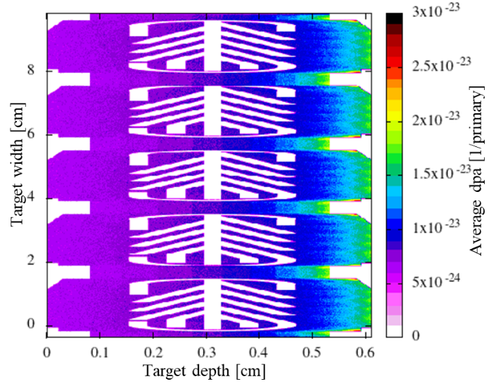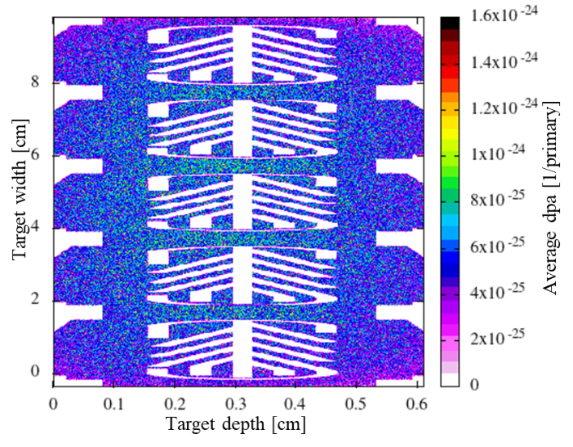

Fig. (a) DPA induced by protons (b) DPA induced by neutrons of the complete target

The minimum lifetimes are estimated based on the reference DPA values derived from irradiation tests of the tantalum target operated for ISIS, i.e. 11 dpa [17], [34] for proton-induced damage and 0.14 dpa [35] for the damage rates of neutrons, as depicted in Table 5. According to the total integrated values of the average DPA induced by protons and neutrons over the target, the lifetimes of 6.0 and 1.3 years are predicted respectively, which are higher than the estimation of 2.62 and 0.78 years reported in [33]. The reason is the target in [33] is a solid tantalum target without water channels inside and the target thickness is 0.5 cm, where the top point of Bragg peak occurs exactly according to Fig.3(a). In this case, the highest energy loss of protons occurs inside the target, and then more protons accumulate there, thus causing higher DPA damage and shorter service life.

Table Estimation of the minimum target lifetime

|  |  |  |  |  |
| --- | --- | --- | --- | --- |
|  | Annual dose [dpa/fpy] | | Minimum target lifetime [years] | |
|  | Reference values | Calculated values | This work | Reference [33] |
| Protons-induced | 11 | 1.82±0.02 | 6.0 | 2.62 |
| Neutrons-induced | 0.14 | 0.11±0.02 | 1.3 | 0.78 |

**5 Conclusions**

An optimized microchannel tantalum target for a low energy (proton beam 70 MeV) accelerator-driven neutron source was obtained by parameter optimizations. The challenge in such a design is the hydrogen embrittlement and blistering problem because of the high average proton current of 8.74×1015 s-1 focusing on a target surface of 100 cm2 and high heat load release in the thin target, and thermal stresses due to inhomogeneous energy deposition. It is resolved by determining an optimized internal cooling microchannel structure matching the energy of the proton beam and a proper target thickness, which is slightly smaller than the ion penetration depth. In this optimized design more than 95% of protons are dumped into the beamstop and only 4.4% of protons accumulate in the target, which strongly minimizes the risk of hydrogen damage. A cross-sectional area of cooling channels of 164 mm2 are used to dissipate heat. Also, a homogenous proton fluence and energy deposition can be obtained by this target design, which can efficiently decrease thermal stresses caused by temperature gradients. Last but not least, based on the damage induced by neutrons, a minimum lifetime of 1.3 years is predicted.

This work provides an efficient and practical target design to produce high neutron yield with a limited hydrogen implantation, which will be of benefit in the development of compact accelerator-based neutron sources.

**6 Outlook**

The target design obtained in this work is the result of a parameter optimization with FLUKA simulations, which aims to minimize the risk of hydrogen damage and achieve a homogeneous energy deposition. Further investigations with ANSYS to check the mechanical and thermal-mechanical properties are in progress. An iterative optimization will be conducted. A prototype will be manufactured to conduct an experiment with a high-power electron beam to determine the critical heat flux at the metal-water boundary and also the maximum power which the target can withstand.

**CRediT authorship contribution statement**

**Qi Ding:** Writing-original draft, Data curation, Visualization, Investigation. **Ulrich Rücker:** Writing-review & editing,Methodology, Supervision. **Paul Zakalek:** Writing-review & editing, Methodology, Supervision. **Johannes Baggemann:** Investigation. **Jörg Wolters:** Investigation. **Jingjing Li:** Writing - review & editing, Methodology, Supervision. **Yannick Beßler:** Investigation. **Thomas Gutberlet:** Project administration, Writing - review & editing, Supervision. **Thomas Brückel:** Resources, Funding acquisition. **Ghaleb Natour:** Resources, Supervision.

**Declaration of competing interest**

The authors declare that they have no known competing financial interests or personal relationships that could have appeared to influence the work reported in this paper.

**Acknowledgments**

Financial support from the China Scholarship Council (CSC) (No.201906310128) is gratefully acknowledged.

**References**

[1] N. Nandakumaran *et al.*, ‘Unravelling Magnetic Nanochain Formation in Dispersion for In Vivo Applications’, *Advanced Materials*, vol. 33, no. 24, Jun. 2021, doi: 10.1002/adma.202008683.

[2] T. Köhler *et al.*, ‘Mechanism of magnetization reduction in iron oxide nanoparticles’, *Nanoscale*, vol. 13, no. 14, pp. 6965–6976, Apr. 2021, doi: 10.1039/d0nr08615k.

[3] S. Bouat *et al.*, ‘Detection of hydrate plugs inside submarine pipelines using neutrons’, *Nondestructive Testing and Evaluation*, vol. 37, pp. 1–13, Oct. 2021, doi: 10.1080/10589759.2021.1990284.

[4] E. Mauerhofer *et al.*, ‘Prompt gamma rays from fast neutron inelastic scattering on aluminum, titanium and copper’, *J Radioanal Nucl Chem*, Aug. 2022, doi: 10.1007/s10967-022-08435-6.

[5] T. Brückel *et al.*, ‘Low energy accelerator-driven neutron sources: Closing the gap and shaping the future’, *Neutron News*, vol. 31, no. 2–4. Bellwether Publishing, Ltd., pp. 2–3, 2020. doi: 10.1080/10448632.2020.1826231.

[6] U. Rücker *et al.*, ‘The Jülich high-brilliance neutron source project’, *The European Physical Journal Plus*, vol. 131, no. 1, p. 19, 2016, doi: 10.1140/epjp/i2016-16019-5.

[7] T. Gutberlet *et al.*, ‘Sustainable neutrons for today and tomorrow—The Jülich High Brilliance neutron Source project’, *Neutron News*, vol. 31, no. 2–4, pp. 37–43, 2020, doi: 10.1080/10448632.2020.1819132.

[8] T. Brückel, T. Gutberlet, S. Schmidt, C. Alba-Simionesco, F. Ott, and A. Menelle, ‘Low energy accelerator-driven neutron facilities—A prospect for a brighter future for research with neutrons’, *Neutron News*, vol. 31, no. 2–4, pp. 13–18, 2020, doi: 10.1080/10448632.2020.1819125.

[9] M. Rimmler *et al.*, ‘Proton Beam Multiplexer Developments for Multi-Target Operation at the High-Brilliance Neutron Source HBS’, *EPJ Web Conf*, vol. 231, p. 02002, 2020, doi: 10.1051/epjconf/202023102002.

[10] I. S. Anderson *et al.*, ‘Research opportunities with compact accelerator-driven neutron sources’, *Phys Rep*, vol. 654, pp. 1–58, 2016, doi: https://doi.org/10.1016/j.physrep.2016.07.007.

[11] Letourneau Alain *et al.*, ‘Development of compact accelerator neutron source’, *EPJ Web Conf.*, vol. 146, p. 3018, 2017, doi: 10.1051/epjconf/201714603018.

[12] P. Zakalek, P.-E. Doege, J. Baggemann, E. Mauerhofer, and T. Brückel, ‘Energy and target material dependence of the neutron yield induced by proton and deuteron bombardment’, *EPJ Web Conf*, vol. 231, p. 03006, 2020, doi: 10.1051/epjconf/202023103006.

[13] A. San-Martin and F. D. Manchester, ‘The H-Ta (hydrogen-tantalum) system’, *Journal of Phase Equilibria*, vol. 12, no. 3, pp. 332–343, 1991, doi: 10.1007/BF02649922.

[14] X. S. Kong *et al.*, ‘First-principles calculations of hydrogen solution and diffusion in tungsten: Temperature and defect-trapping effects’, *Acta Mater*, vol. 84, pp. 426–435, Feb. 2015, doi: 10.1016/j.actamat.2014.10.039.

[15] V. T. Astrelin *et al.*, ‘Blistering of the selected materials irradiated by intense 200 keV proton beam’, *Journal of Nuclear Materials*, vol. 396, no. 1, pp. 43–48, Jan. 2010, doi: 10.1016/j.jnucmat.2009.10.051.

[16] T. Schober, ‘Vanadium-, niobium- and tantalum-hydrogen’, *Solid State Phenomena*, vol. 49–50, pp. 357–422, 1996, doi: 10.4028/www.scientific.net/ssp.49-50.357.

[17] J. Chen *et al.*, ‘Summary of the results from post-irradiation examination of spent targets at the FZ-Juelich’, in *Journal of Nuclear Materials*, May 2003, vol. 318, no. SUPPL, pp. 56–69. doi: 10.1016/S0022-3115(03)00007-2.

[18] ‘CONCEPTUAL DESIGN OF THE PROTON LINAC FOR THE HIGH BRILLIANCE NEUTRON SOURCE HBS’, 2019, doi: 10.18429/JACoW-IPAC2019-MOPTS027.

[19] M. R. Louthan, G. R. Caskey, J. A. Donovan, and D. E. Rawl, ‘Hydrogen embrittlement of metals’, *Materials Science and Engineering*, vol. 10, pp. 357–368, 1972, doi: https://doi.org/10.1016/0025-5416(72)90109-7.

[20] V. T. Astrelin *et al.*, ‘Blistering of the selected materials irradiated by intense 200 keV proton beam’, *Journal of Nuclear Materials*, vol. 396, no. 1, pp. 43–48, Jan. 2010, doi: 10.1016/j.jnucmat.2009.10.051.

[21] YU. v. Martynenko, ‘The theory of blister formation’, *Radiat Eff*, vol. 45, no. 1–2, pp. 93–101, Jan. 1979, doi: 10.1080/00337577908208414.

[22] S. G. Kandlikar, ‘Heat transfer mechanisms during flow boiling in microchannels’, *J Heat Transfer*, vol. 126, no. 1, pp. 8–16, Feb. 2004, doi: 10.1115/1.1643090.

[23] S. G. Kandlikar, ‘Chapter 5 - Flow boiling in minichannels and microchannels’, in *Heat Transfer and Fluid Flow in Minichannels and Microchannels*, S. G. Kandlikar, S. Garimella, D. Li, S. Colin, and M. R. King, Eds. Oxford: Elsevier Science Ltd, 2006, pp. 175–226. doi: https://doi.org/10.1016/B978-008044527-4/50007-4.

[24] N. Simos *et al.*, ‘Multi-MW accelerator target material properties under proton irradiation at Brookhaven National Laboratory linear isotope producer’, *Physical Review Accelerators and Beams*, vol. 21, no. 5, May 2018, doi: 10.1103/PhysRevAccelBeams.21.053001.

[25] P. Mastinu *et al.*, ‘Micro-channel-based high specific power lithium target’, *Nuovo Cim. C*, vol. 38, no. 6, p. 193, 2016, doi: 10.1393/ncc/i2015-15193-y.

[26] B. C. Kandpal, J. kumar, and H. Singh, ‘Machining of Aluminium Metal Matrix Composites with Electrical Discharge Machining - A Review’, *Mater Today Proc*, vol. 2, no. 4–5, pp. 1665–1671, Jan. 2015, doi: 10.1016/J.MATPR.2015.07.094.

[27] T. T. Böhlen *et al.*, ‘The FLUKA Code: Developments and Challenges for High Energy and Medical Applications’, *Nuclear Data Sheets*, vol. 120, pp. 211–214, 2014, doi: https://doi.org/10.1016/j.nds.2014.07.049.

[28] A. Ferrari, P. R. Sala, A. Fasso, and J. Ranft, ‘FLUKA: A multi-particle transport code (Program version 2005)’, Sep. 2005, doi: 10.2172/877507.

[29] D. A. Brown *et al.*, ‘ENDF/B-VIII.0: The 8th Major Release of the Nuclear Reaction Data Library with CIELO-project Cross Sections, New Standards and Thermal Scattering Data’, *Nuclear Data Sheets*, vol. 148, pp. 1–142, Feb. 2018, doi: 10.1016/j.nds.2018.02.001.

[30] S. Kunieda *et al.*, ‘Overview of JENDL-40/HE and benchmark calculations’, Japan, 2016. [Online]. Available: http://inis.iaea.org/search/search.aspx?orig_q=RN:48045186

[31] W. Ulmer and E. Matsinos, ‘Theoretical methods for the calculation of Bragg curves and 3D distributions of proton beams’, *European Physical Journal: Special Topics*, vol. 190, no. 1. pp. 1–81, 2010. doi: 10.1140/epjst/e2010-01335-7.

[32] G. Pluvinage, ‘Notch Effects in Fatigue and Fracture’, in *Notch Effects in Fatigue and Fracture*, G. Pluvinage and M. Gjonaj, Eds. Dordrecht: Springer Netherlands, 2001, pp. 1–22. doi: 10.1007/978-94-010-0880-8_1.

[33] N. Ophoven *et al.*, ‘Monte Carlo simulation of proton- and neutron-induced radiation damage in a tantalum target irradiated by 70 MeV protons’, *Appl Phys A Mater Sci Process*, vol. 127, no. 8, Aug. 2021, doi: 10.1007/s00339-021-04713-4.

[34] J. Chen *et al.*, ‘Mechanical properties of pure tantalum after 800 MeV proton irradiation’, *Journal of Nuclear Materials*, vol. 298, no. 3, pp. 248–254, 2001, doi: https://doi.org/10.1016/S0022-3115(01)00654-7.

[35] T. S. Byun and S. A. Maloy, ‘Dose dependence of mechanical properties in tantalum and tantalum alloys after low temperature irradiation’, *Journal of Nuclear Materials*, vol. 377, no. 1, pp. 72–79, Jun. 2008, doi: 10.1016/j.jnucmat.2008.02.034.